Smudge Pot Fundraiser

WHEN
Monday August 26, 2013
Tuesday August 27, 2013
Wednesday August 28, 2013

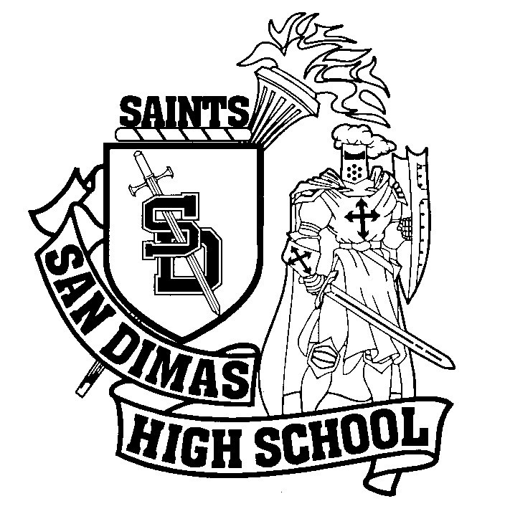

Where
2212 Foothill Blvd, La Verne CA
In the Osh shopping Center

VS
Circle your team!
2 ways to win!
Student!
Bring your student I.D. card to receive your Student Meal Deal. A chip, a 22 oz drink, and a Regular Jersey Mike’s Sub for only $6.95
Parents!
Come in with this flyer and receive the Mikes Meal Deal, each meal includes: a chip, a 22 oz drink, and a Regular Jersey Mikes Sub for $7.99

Each meal purchased will earn a Dollar for your School!!!

