Do you need a night without the kids? Need sometime to relax and enjoy yourself?
Parents Night Out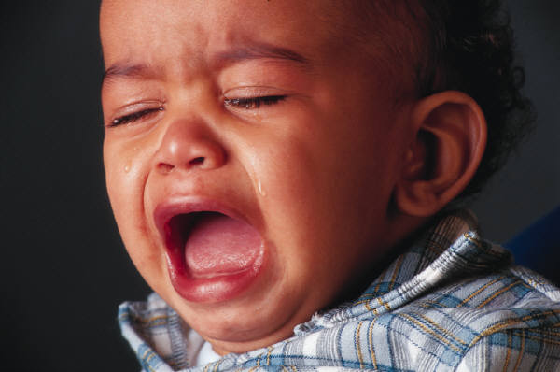
The San Dimas High School cheer squad is here for you! Bring your children to SDHS and let us watch the kids for a night!

When: September 14, 2013
Time: 5:00- 10:00 pm
Where: San Dimas High School (Gym)
Price: $25.00
What to Bring: Blanket

We will be playing games, doing a craft, watching a movie, and having fun!

Registration Form
Name:
Age:
Emergency Contact
Name:
Phone Number:

